DAY 26 –LECTURE NOTE
Tuesday, October 29th, 2019.

INVENTORY MGMT. SYST.
An Inventory Management System (IMS) is an enterprise software for tracking stocked items, orders, sales and deliveries. Stocked items may include products, services, business assets, etc.

USE CASE
In software engineering, a use case is a list of actions or events that defines the interaction between a system operator (referred to as an actor) and a system in order to achieve a particular goal. It is important to note that use cases do not necessarily state the authorization levels of actors when defining roles.

Use cases for an Inventory Management System are as follows;
- Register – Actors must have an account in order to utilize system facilities.
- Login/Logout – Actors should be required to sign in/out to access system facilities.
- Dashboard (Progress Report) – Actors should be able to view a summary of account and system activities.
- Manage Account –Actors should be able to view and modify their account information.
- Manage Stock – Actors should be able to create, read, update and delete stocked items.
- Manage Sales – Actors should be able to create, read, update and delete sales records.
- Settings – Actors should be able to configure system facilities based on certain preferences.

Note: At a glance, a dashboard may also include Key Performance Indictors (KPIs) derived from comprehensive analysis of related datasets in a database. Read up Business Intelligence.

USE CASE DIAGRAM
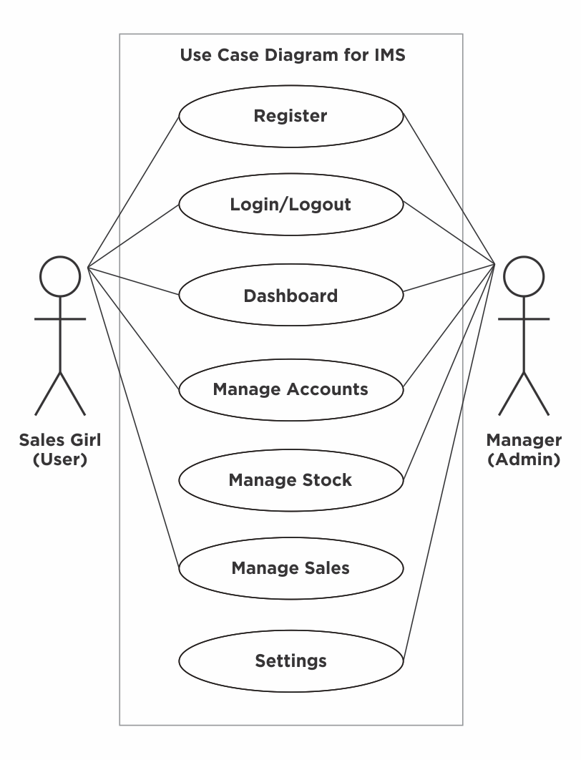
A use case diagram is a standardized illustration of the relationship between actors and use cases in a system. Use cases are represented as titled ellipses within a vertical rectangle (referred to as the system boundary), and actors are represented as stick figures. Occasionally, users are represented on the left side of the system boundary and admins on the right.

